Robert Minson

SYS-400

Prof. Dilts

November 30, 2022

Data Disk Storage, Backup, & Recovery

1. The process to storing data on a disk is not long nor painful. First step is to open your SQL. From here you will right click on your database that you wish to backup. Then click the option that says back up and a new window will pop up. In that window, go to backup type and select full to make sure that everything is being saved, then select ok. A new window will pop up saying that the backup of the database has be successfully completed. Now right click the database again and select restore, another new window will appear. Near the bottom of the window, you will have the option to select one of the backups you have made for that database. Select the back up that you just made moments ago then click ok. Make sure you do not have any queries open when you do this. Once you hit ok, the restore process will begin, and once completed a new small window will pop up with a message saying that the restore was successfully completed.
2. 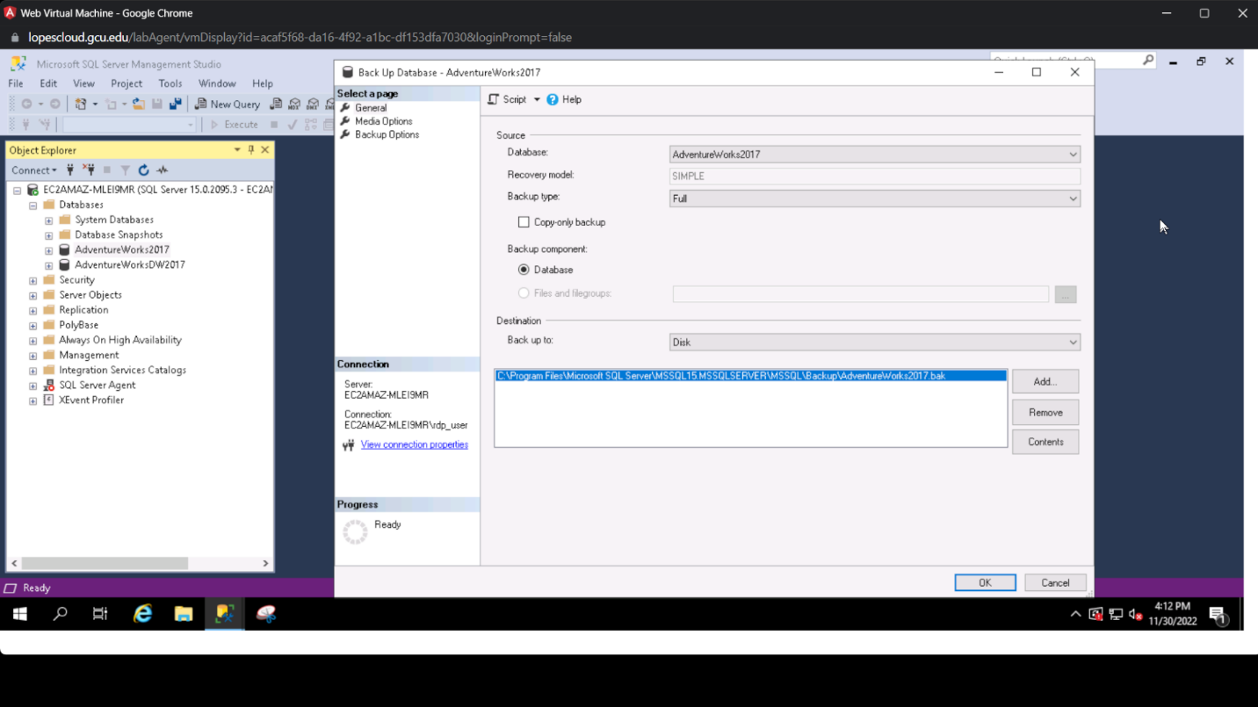
3. 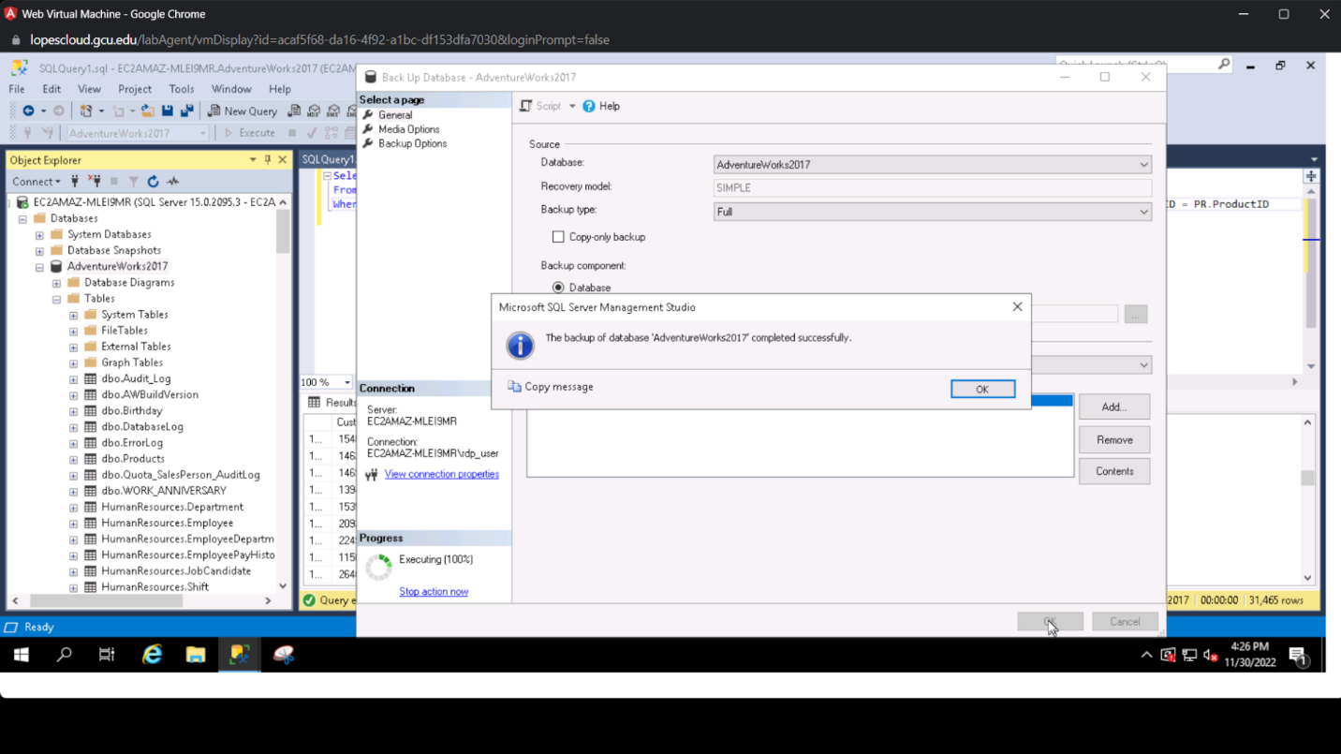
4. 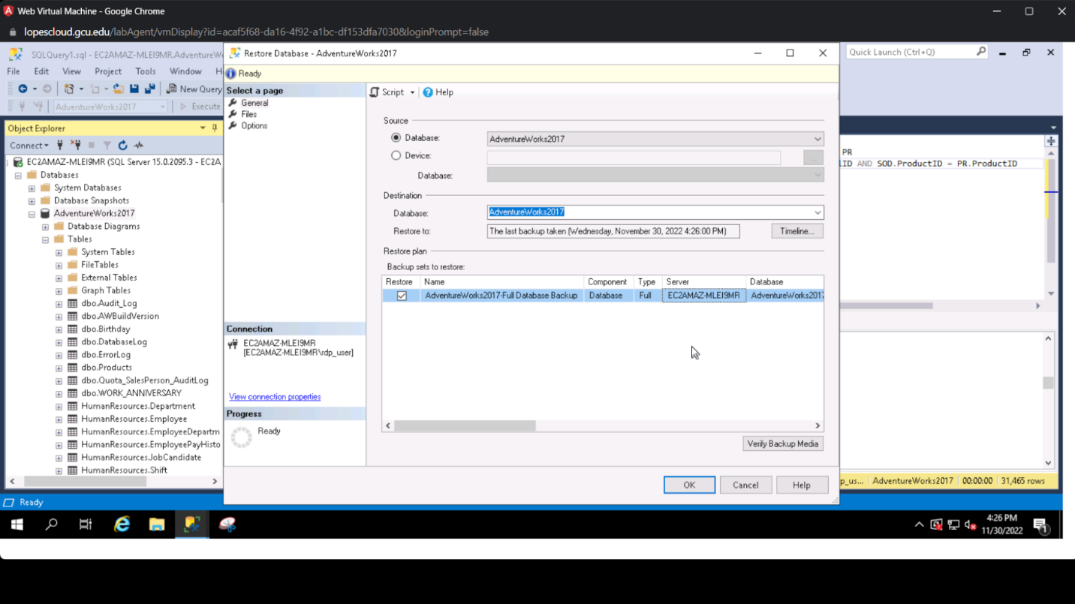
5. 